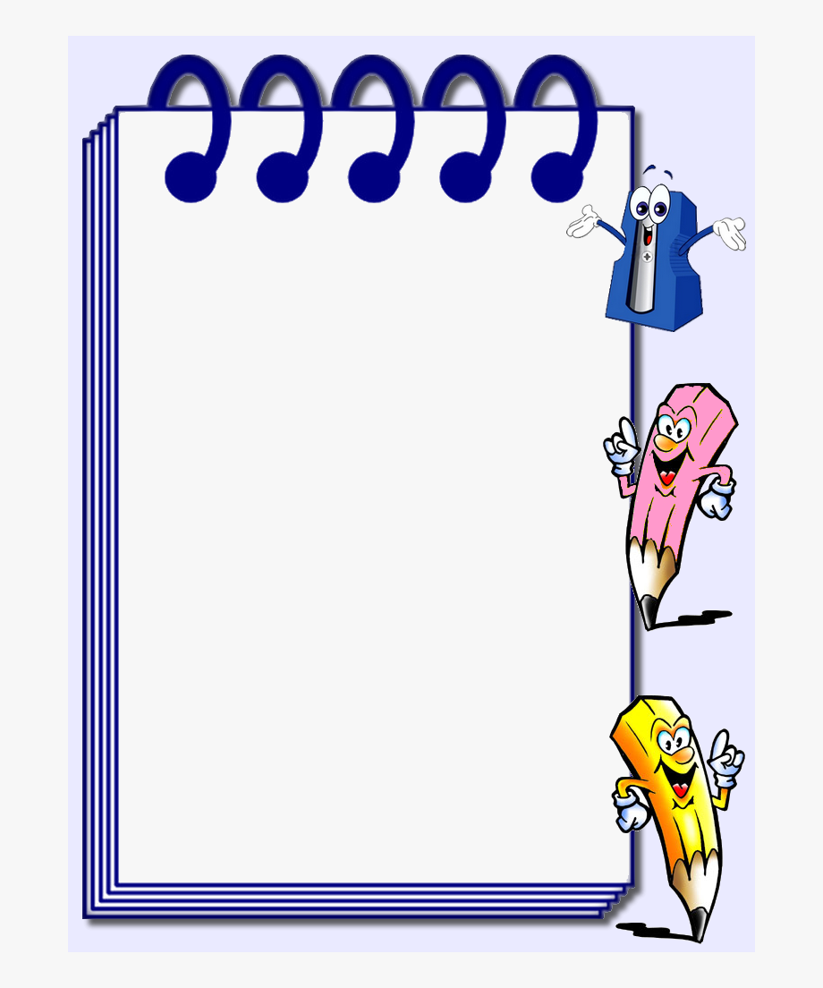

**CAA Pre-K & Kindergarten School Supply List**

$25 fee for general supplies purchased for student use

1 backpack

1 water bottle (Pop Top – that won’t spill)

1 Kinder Mat (red/blue) – leave at school

1 small blanket and small pillow (Please send to school every Monday, they will be sent home on Friday)

*We understand it may be difficult to get some items. Please get what you can.